HTML

Task-1:

Create First code.html.

Type your 1st code using heading <h1> to <h6> and paragraph <p> tags of the following sentence,

Hello HTML!

By: “You’re Name”

Date: “Todays Date”

Your goal for this course.

Output:

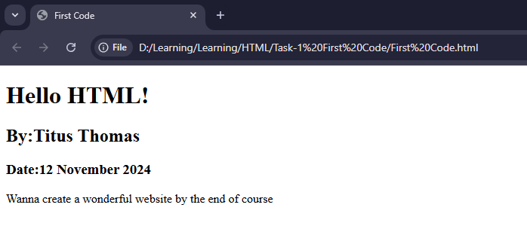

Task-2:

Create Elementals.html.

Print the following elements with corresponding emoji’s using the HTML elements.

* Fire
* Water
* Earth
* Air

Output:

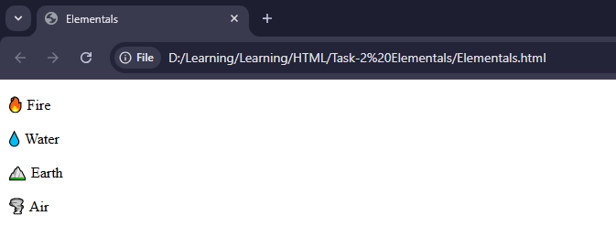

Task-3: